CSCE 567 – Visualization Tools
JavaScript/D3 Homework
Deliverable: You will attach an html file (in a compressed .zip file) that produces a scatter plot and bar chart using JavaScript with D3 that fulfills the requirements described below.
The Data: Your visualizations will use the Department of Transportation’s data on licensed drivers and vehicle registrations that is accessible on data.gov at https://catalog.data.gov/dataset/licensed-drivers-vehicle-registrations-and-resident-population-dv-1c. You should link to the data using the D3 csv function with the URL: https://data.transportation.gov/api/views/9hnm-fr6r/rows.csv
Scatterplot Requirements:
(1 points) The scatterplot can use two of the numeric fields to explore the relationship between them.
The example scatterplot pictured below shows the relationship between the number of licensed drivers and the number of registered vehicles.
(0.5 point) The scatterplot should use color to represent something meaningful in the visualization.
The example scatterplot pictured below uses different colors to represent whether or not the number of licensed drivers is larger than the number of registered vehicles.
(0.5 point) The scatterplot should use the title element to display all pertinent information the circle represents.

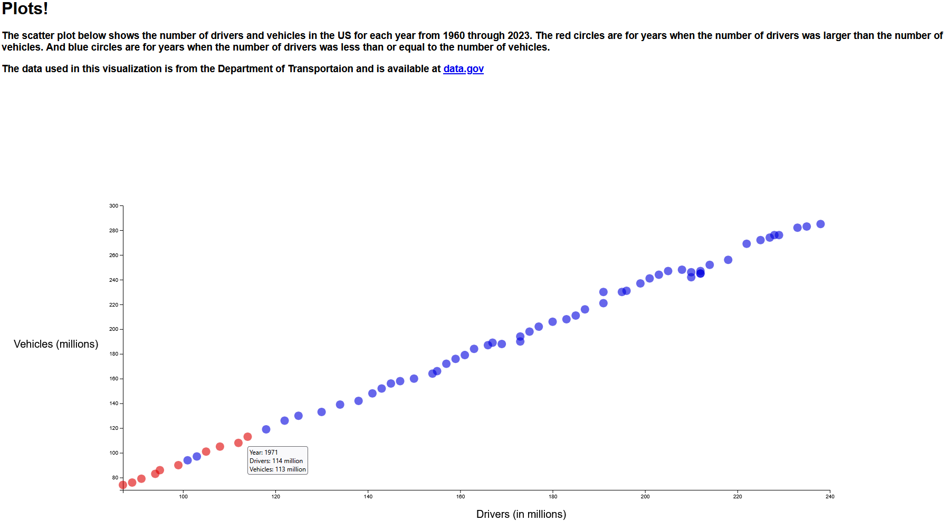

Bar Chart Requirements:
(1 points) The bar chart should show one of the numeric values over the years included in the dataset (1960-2023).
The example bar chart pictured below shows the number of registered vehicles for each year.
(0.5 point) The bar chart should use mouseover events to highlight (change the color) of a bar when the user moves their mouse over it. Alternatively, you can apply a CSS class and then use the ":hover" functionality built into CSS
(0.5 point) The scatterplot should use the title element to display the year and quantity the bar represents.

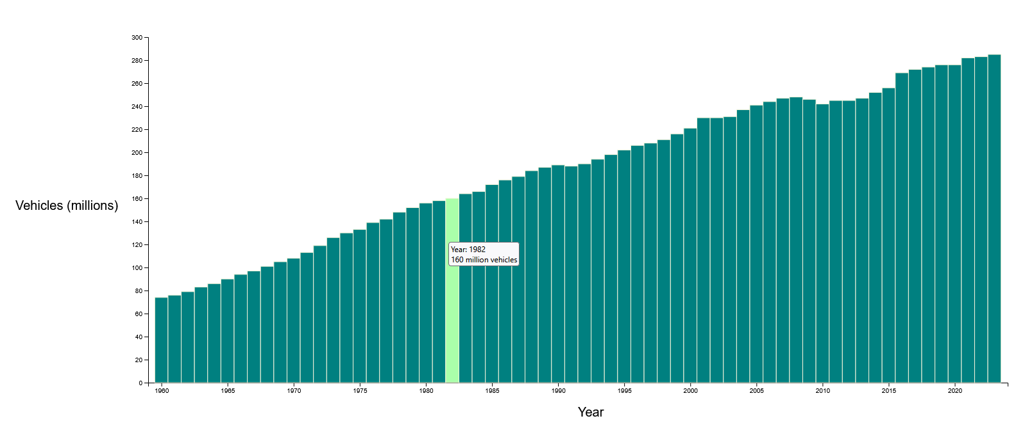

Descriptive Text / Link (1 points):
Add a short description of your visualization at the top of the page with a link to the dataset on data.gov.

Save and Submit:
Note: Blackboard is finicky about accepting html file attachments. Compress the file into a .zip file, and upload the zip file to the assignment in Blackboard.

